**WEB APPLICATION DEVELOPMENT LAB**

**30-1-2025**

Eshwar Deshmukh Chavan

HU22CSEN0100999

1. JavaScript program to convert object to strings

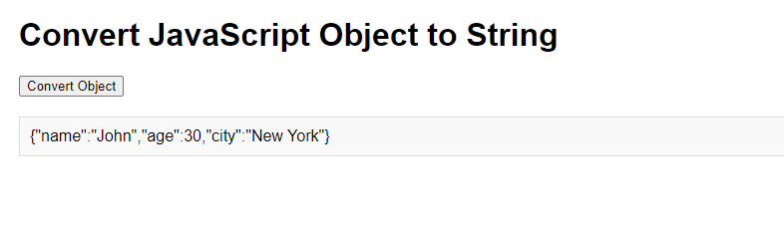

Code:

<!DOCTYPE html>

<html lang="en">

<head>

<meta charset="UTF-8">

<meta name="viewport" content="width=device-width, initial-scale=1.0">

<title>Object to String Example</title>

<style>

body {

font-family: Arial, sans-serif;

margin: 20px;

}

#output {

margin-top: 20px;

padding: 10px;

border: 1px solid #ddd;

background-color: #f9f9f9;

}

</style>

</head>

<body>

<h1>Convert JavaScript Object to String</h1>

<button onclick="convertObjectToString()">Convert Object</button>

<div id="output"></div>

<script>

const obj = {

name: "John",

age: 30,

city: "New York"

};

function convertObjectToString() {

const jsonString = JSON.stringify(obj);

document.getElementById("output").innerText = jsonString;

}

</script>

</body>

</html>

2. converting JavaScript object to json

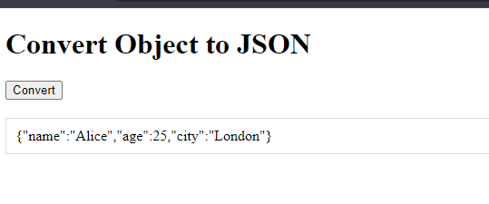

CODE:

<!DOCTYPE html>

<html lang="en">

<head>

<meta charset="UTF-8">

<meta name="viewport" content="width=device-width, initial-scale=1.0">

<title>Object to JSON Example</title>

</head>

<body>

<h1>Convert Object to JSON</h1>

<button onclick="convertToJson()">Convert</button>

<div id="jsonOutput" style="margin-top: 20px; padding: 10px; border: 1px solid #ddd;"></div>

<script>

function convertToJson() {

const person = {

name: "Alice",

age: 25,

city: "London"

};

const jsonString = JSON.stringify(person);

document.getElementById('jsonOutput').innerText = jsonString;

}

</script>

</body>

</html>

3. fetch product details from a json file and display them dynamically on a webpage

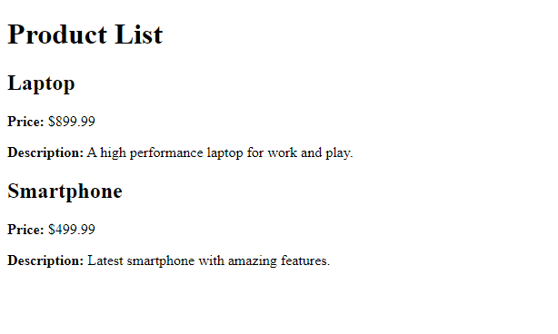

JSON :

[

{

"id": 1,

"name": "Laptop",

"price": 899.99,

"description": "A high performance laptop for work and play."

},

{

"id": 2,

"name": "Smartphone",

"price": 499.99,

"description": "Latest smartphone with amazing features."

}

]

CODE:

<!DOCTYPE html>

<html lang="en">

<head>

<title>Product List</title>

</head>

<body>

<h1>Product Details</h1>

<div id="product-list"></div>

<script>

fetch('products.json')

.then(response => response.json())

.then(products => {

s

let productList = document.getElementById('product-list');

products.forEach(product => {

let productItem = document.createElement('div');

productItem.innerHTML = `

<strong>${product.name}</strong><br>

Price: $${product.price}<br>

Description: ${product.description}<br><br>

`;

productList.appendChild(productItem);

});

})

.catch(error => console.error('Error fetching product data:', error));

</script>

</body>

</html>

4. Record expenses in json format and calculate total expenses

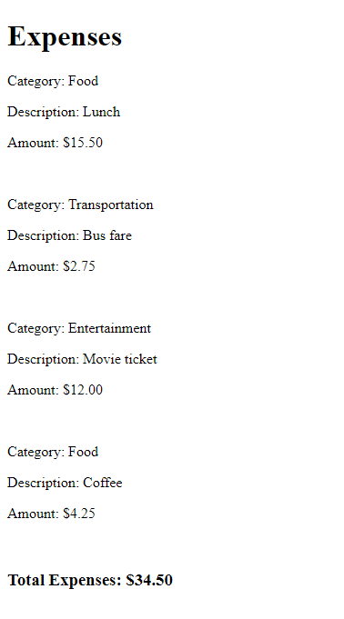

JSON:

[

{

"category": "Food",

"description": "Lunch",

"amount": 15.50

},

{

"category": "Transportation",

"description": "Bus fare",

"amount": 2.75

},

{

"category": "Entertainment",

"description": "Movie ticket",

"amount": 12.00

},

{

"category": "Food",

"description": "Coffee",

"amount": 4.25

}

]

CODE:

<!DOCTYPE html>

<html lang="en">

<head>

<meta charset="UTF-8">

<meta name="viewport" content="width=device-width, initial-scale=1.0">

<title>Expenses Tracker</title>

</head>

<body>

<h1>Expenses</h1>

<div id="expense-list"></div>

<h3>Total Expenses: $<span id="total-expenses">0.00</span></h3>

<script>

fetch('expenses.json')

.then(response => response.json())

.then(data => {

const expenseList = document.getElementById('expense-list');

let totalExpenses = 0;

data.forEach(expense => {

const expenseDiv = document.createElement('div');

expenseDiv.innerHTML = `

<p>Category: ${expense.category}</p>

<p>Description: ${expense.description}</p>

<p>Amount: $${expense.amount.toFixed(2)}</p>

<hr>

`;

expenseList.appendChild(expenseDiv);

totalExpenses += expense.amount;

});

document.getElementById('total-expenses').innerText = totalExpenses.toFixed(2);

})

.catch(error => console.error('Error loading the expense data:', error));

</script>

</body>

</html>